Dev C++ 4.9.9.2 Installation Guide

Step 1:
Double click on the file devcpp_setup.exe and Click on “Run” button.

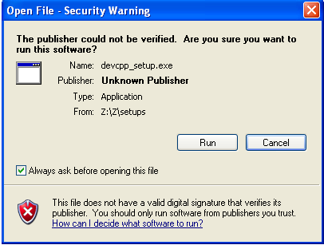
Step 2:
Click on “OK” button.

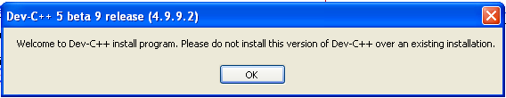
Step 3:
Click on “OK” button.

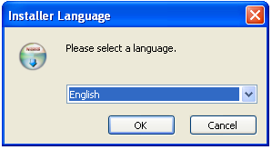
Step 4:
Click on “I Agree ” button.

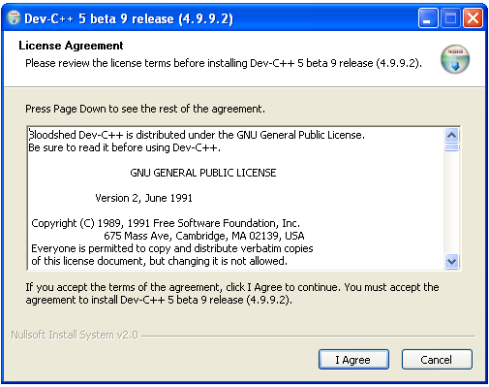

Step 5:
Click on “Next” button.

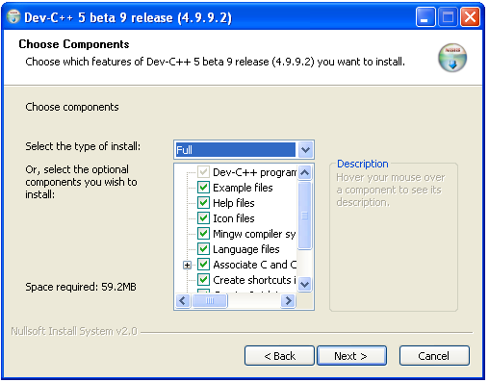
Step 6:
Click on “Install” button.

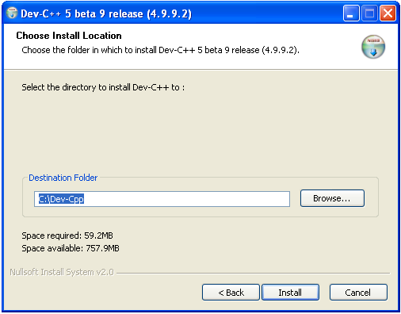
Step 7:
Wait until the green bar completed
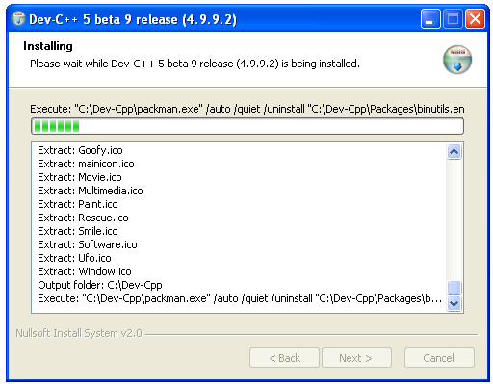
Step 8:
Click on “Finish” button.
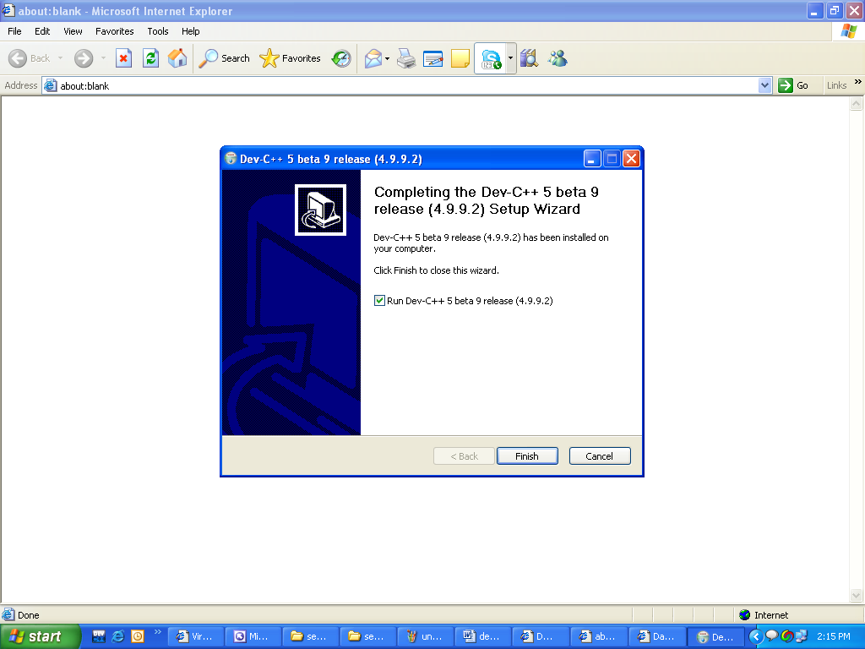

Well Done!
Your Dev C++ 4.9.9.2 has been installed successfully. Now start writing compiling and running programs and enjoy programming

BEST OF LUCK

